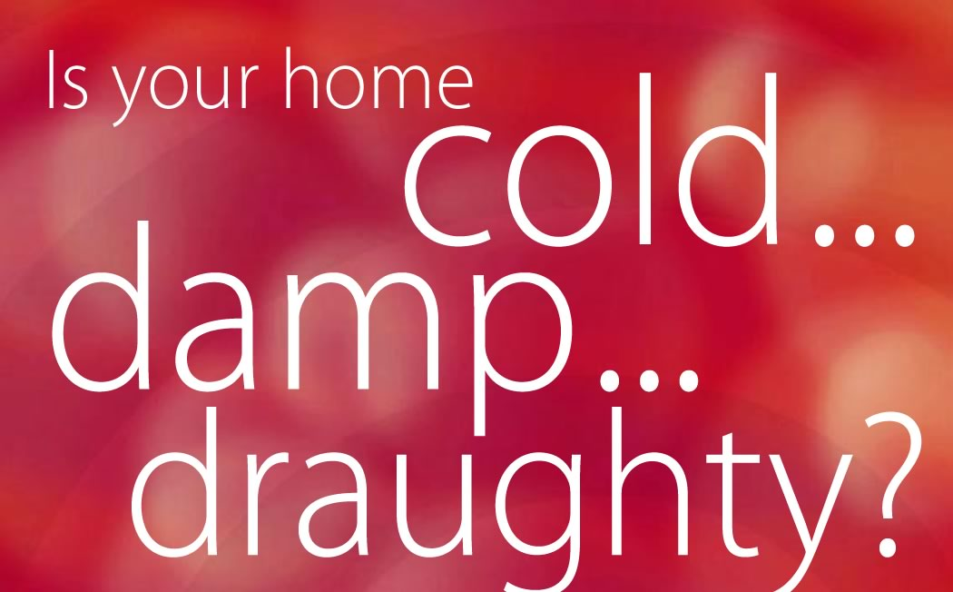
Are you either a home-owner or a private tenant?
Are you receiving benefits because of ill health,
disability or low income?

If the answer is ‘Yes’ to both questions, you might be
able to get a grant of up to £2,700 to spend on insulation,
central heating, and energy efficiency measures.

TO FIND OUT MORE
To find out if you can get a grant call:
0800 316 6011 (England)
0800 316 2815 (Wales)
0131 777 2501 (Scotland)
0288 775 3636 (Northern Ireland) or
0800 512 012 for your local Energy Efficiency Advice Centre
or ask at Reception for a referral form

The original version of this poster was produced by the National Heart Forum, the Eaga Partnership Charitable Trust, the Faculty of Public Health Medicine,
Help the Aged and the Met Office, as part of the Fuel Poverty and Health Toolkit for primary care organisations and public health and primary care professionals.
For a copy of the toolkit, contact the National Heart Forum, Tavistock House South, Tavistock Square, London WC1H 9LG. T: 020 7383 7638 W: www.heartforum.org.uk.

